**Problem Statement**: Prospects of opening a restaurant in Edmonton, Canada.

**Introduction**：Edmonton, the capital of the province of Alberta, is the fifth-largest municipality in Canada with a population of 0.97 million according to the 2019 municipal census. What is more, it is one of the most populous Canadian cities. Every year, there are more than 30 festivals going on in this city and it is also known as Canada’s Festival City. Based on a recent report from the city of Edmonton, there are increasing numbers of overnight stays and with over 3.3 million overnight visits. As a result, Edmonton is one of the best places to start a service business, such as a restaurant.

In this project, we will go through step by step process to make decisions on:

1. determine the target markets of the restaurant

2. determine the type of restaurant

3. determine the location of the restaurant

By analyzing the neighborhoods in Edmonton, we can identify the potential customers of the restaurant, the type of the restaurant and the most potentially profitable locations since the success of a restaurant depends on a combined analysis of people, location and services:

1. Who will the target customers be? (Demographics: such as age, sex, income, education, religion, race, and geographical location; Psychographics: attitudes, aspirations, and values; Behavior: buyer habits, spending habits, digital behavior, and hobbies)

2. What will you offer them? (Types of the restaurant: such as, traditional fast food/quick-service, fast-casual, casual dining, premium casual, fine dining, family dining; Ethnic of the restaurant: specialize in ethnic or national cuisines)

3. Where can you serve your guests? (Geographical: urban, suburban, rural, which neighborhoods)

4. When will they come to your restaurant? (Opening hours: daytime, nighttime)

5. Why should people come to your restaurant?

**Target Audience of this business report**:

1. Business personnel who wants to invest or open a restaurant in Edmonton. This analysis will be a comprehensive guide to start or expand restaurants in the city of Edmonton.

2. Freelancer who loves to have their own restaurant as a side business. This analysis will give an idea, how beneficial it is to open a restaurant and what are the pros and cons of this business.

3. Crowd who wants to find neighborhoods with lots of option for certain restaurants.

4. Business analyst or data scientist, who wishes to analyze the neighborhoods of Edmonton using exploratory data analysis and other statistical & machine learning techniques to obtain all the necessary data, perform some operations on it and, finally be able to tell a story out of it.

**Data Sources**

a) Data are obtained from “Mature Neighbourhood Reinvestment Report 2017” (<https://www.edmonton.ca/city_government/documents/Mature_Neighbourhood_Reinvestment_Report_2017.pdf>) and open data sources from City of Edmonton official website (<https://www.edmonton.ca/city_government/urban_planning_and_design/building-permit-activities-visualization.aspx>; <https://data.edmonton.ca/dataset/City-Of-Edmonton-Neighbourhood-Boundaries-Spatial-/tvcx-3vrx>) to get all the information about the neighborhoods present in Edmonton. These sources provide the geographical coordinates and relative information of the neighborhoods (name, latitude, longitude, geo-shape, total area), as well as a general classification of the neighborhoods in Edmonton.

b) To get information about the distribution of population by their age, sex, income, education, religion, race, I use open data sources from City of Edmonton and Statistic Canada. Then, based on the previous 10 years census data, I’m going to identify the target customer segmentation in this city and the neighborhoods which are densely populated with the target customers as it might be helpful in identifying the suitable neighborhood to open a restaurant.

c) To get location and other information about various venues in Edmonton I’m using Foursquare, Yelp and Zomato explore API. Using the these explore API (which gives venues recommendations), I’m fetching details about the venues up present in Edmonton and collected their names, categories and locations (latitude and longitude).

**Methodology**:

Edmonton can be shaped either by postal code boundaries, or political Ward boundaries or Neighborhood boundaries. Since, usually, a census report or engine search are based on Neighborhood boundaries, this report will use the Neighborhood boundaries for further analysis.

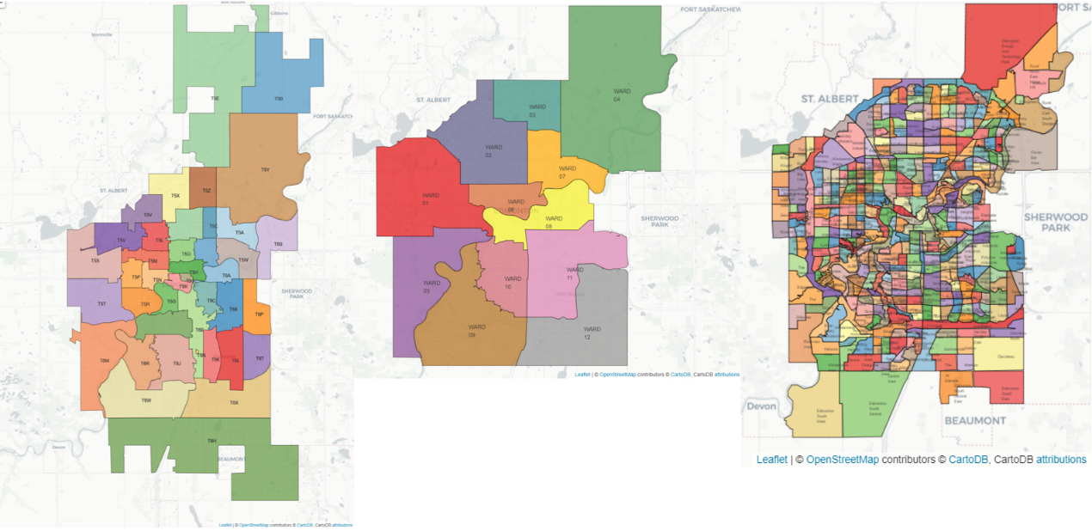

1. **Data cleaning**
2. According to the “Mature Neighbourhood Reinvestment Report 2017” published by the City of Edmonton, the neighborhood can be classified in different zooms. In this report, we will focus on only developing, established, and mature areas (includes central core areas and downtown area).

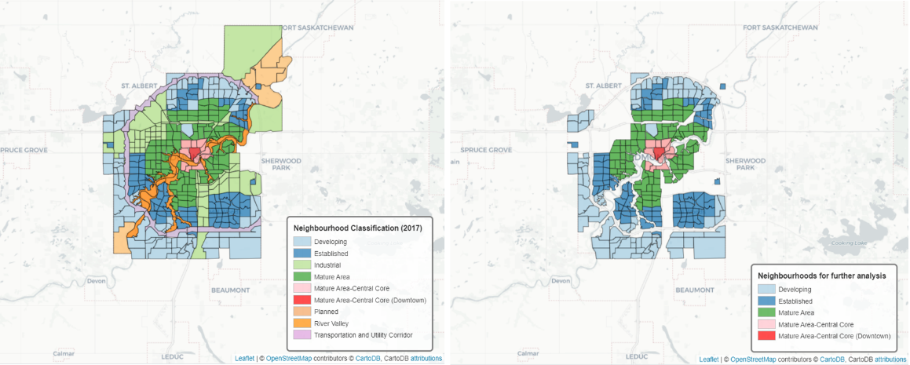

1. Since most of the data are gained from the city-wise census report, according to the city bylaw, a result of a certain question in a neighborhood will not be presented to the public if more than 50% of its total population did response to the question. To make up such missing data, I will use data obtained from the country-wise census report which is special requested from the Statistic Canada.
2. Another thing needs to be notice is that, since the city is developing, for the neighborhoods’ names, there is a lot different in the early years from nowadays. As a result, during data cleaning, it is important to recognize the neighborhoods with different names with time and make them consistent.
3. **Check whether the city is safe to start up a business.**

First of all, it is very important to know whether our target city is safe enough to start a business. By looking into the violence incident data published by the City of Edmonton, we can see that the percentage violation incidence per population is less than 10% for all neighborhoods in developing, established and mature areas. This means the city of Edmonton is a safe place to start a business. What is more, the most commonly occurrence types in this city are vehicle theft, assault, and break and enter. Most of these violation incidences can be avoided by strengthening the vehicle/house security system. Further, if we compare data in the past 10 years, the violation incidents are decreasing in recent years. This indicates that the city is getting safer and better.

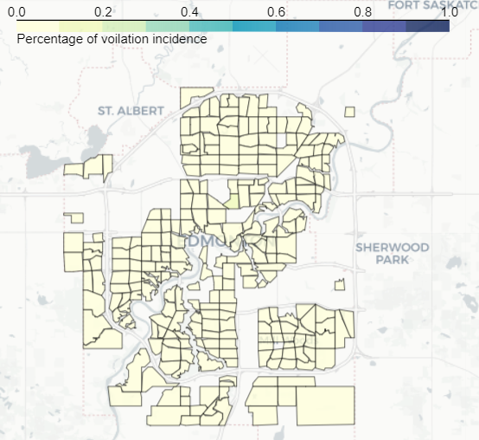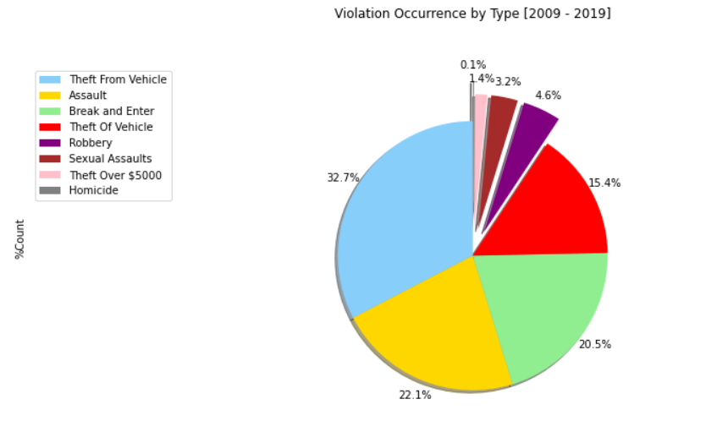

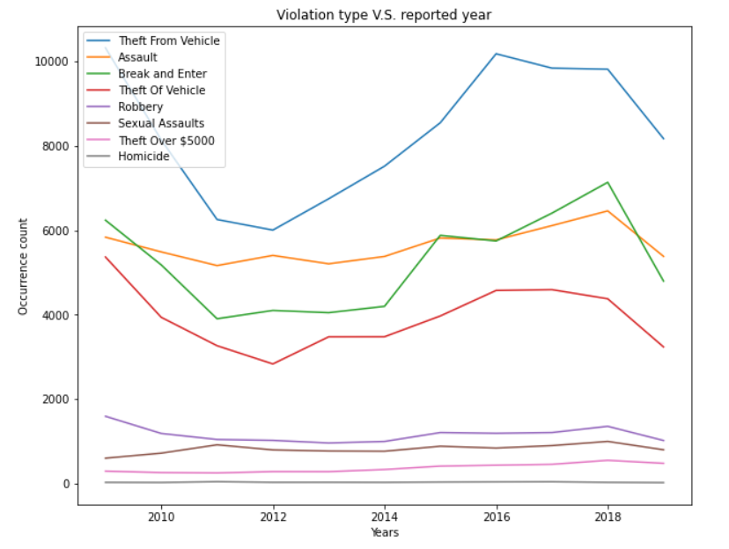

1. **Figure out the target customer segment.**

First, we need make sure that there are increasing numbers of people moving into this city.

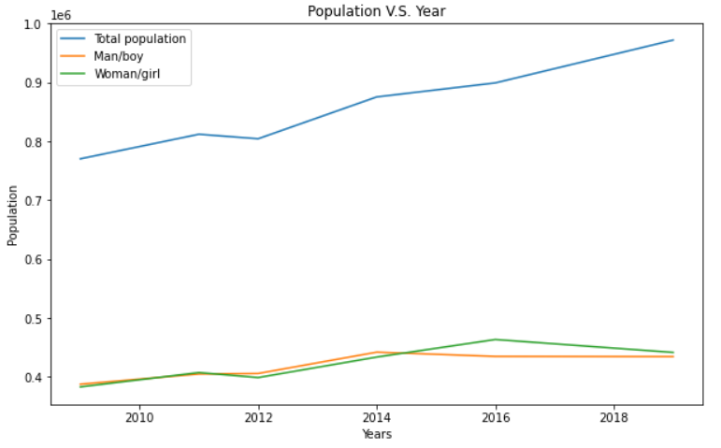

Then, we investigate the marital status in Edmonton. By analyzing the marital data and family size data obtained from the past 20 years’ census reports, we realized that more and more people tend to stay **single**. Also, more and more families tend to **not have a child**.



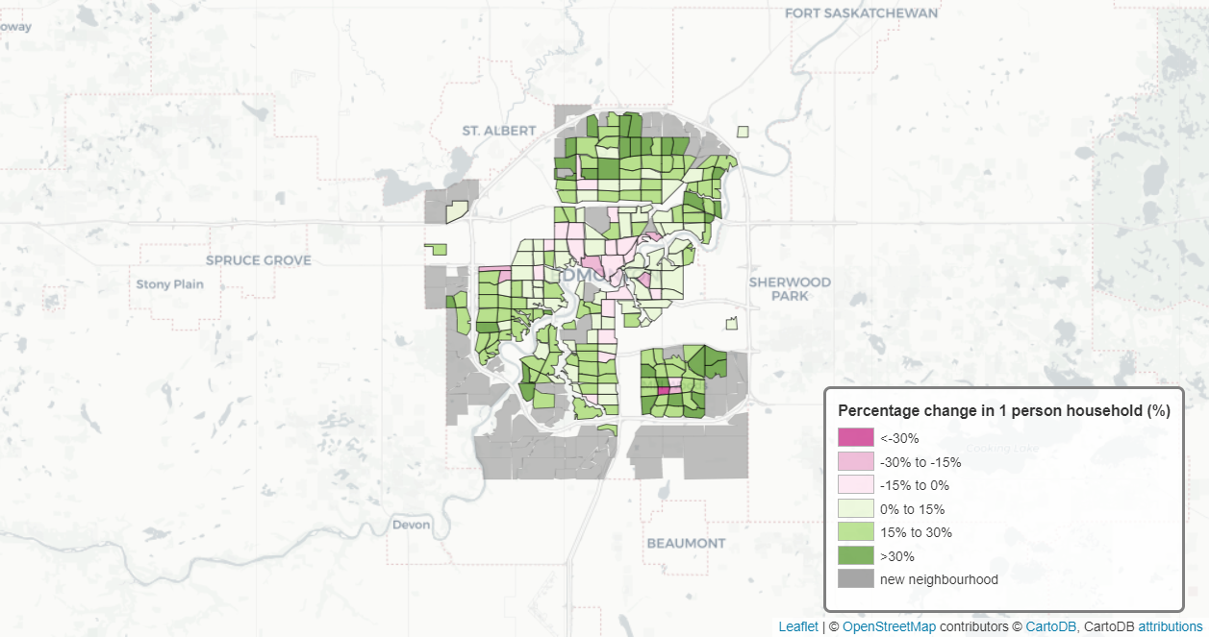



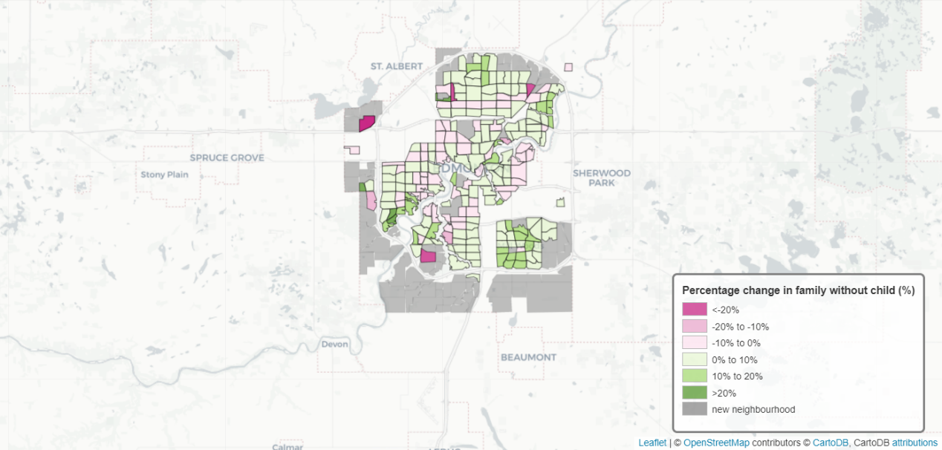

Also, we can investigate the population in Edmonton to figure out the Demographic of our target customer segment. By analyzing the population data obtained from the past 10 years’ census reports, there is no significant difference between genders. According to the age distribution in 2019, the potential customer segments in Edmonton is Millennials, Generation X and Baby Boomers.

Millennials:

1. Eats out more often than the general population, with [53%](http://www.businessinsider.com/millennials-dining-habits-are-different-2015-3) going out to eat at least once a week.
2. Prefers to stay in their part of the city and are looking for a good place to eat right nearby.
3. Most of the Millennials are single or without child.

Generation X:

1. Places a lot of value on family dining.
2. Prefers to have dining in suburban or rural areas.
3. Most of the Generation X are not single or has a child.

Baby boomer:

1. Many baby boomers are report being on a diet. (This means this group of people prefers special food. Opening a restaurant offering special food required special food licenses, and with additional business constrains.)
2. Prefers to have dining in suburban or rural areas.
3. Most of the baby boomers are not single or has a child.

Additionally, according to the 2019 age distribution figure, Millennials has the largest overall population compared to other generations. What is more, based on the figure “the population change of each generation between 2019 and 2009”, it is observed that Millennials is the top riser. As a result, for the rest of this report, we will focus on **Millennials**.



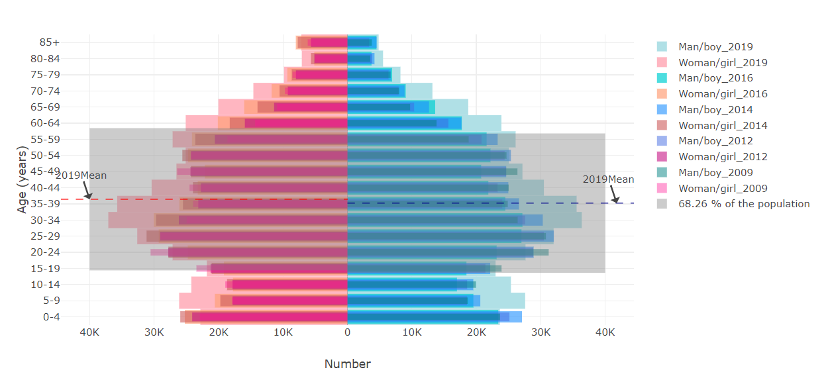

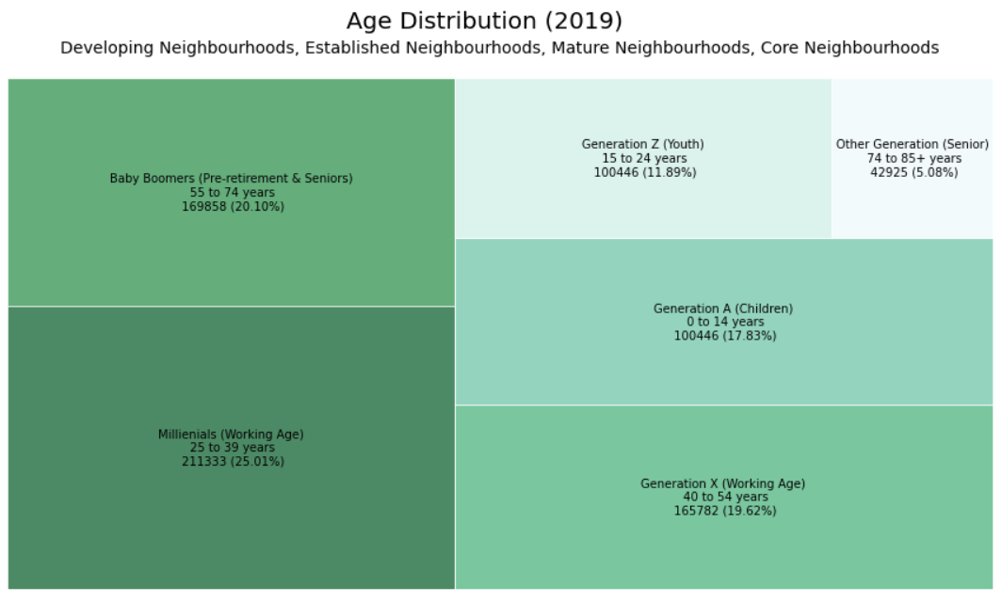

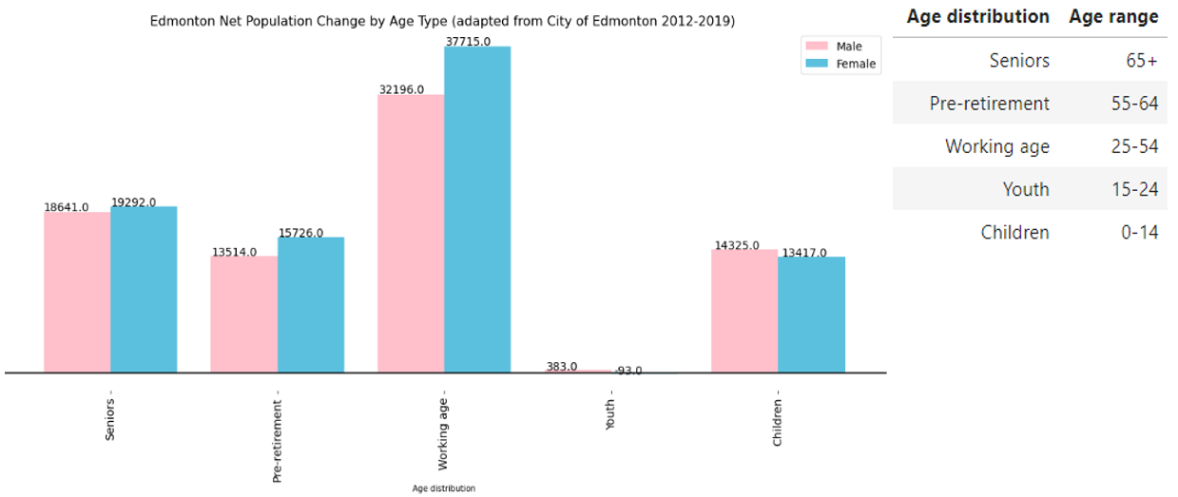

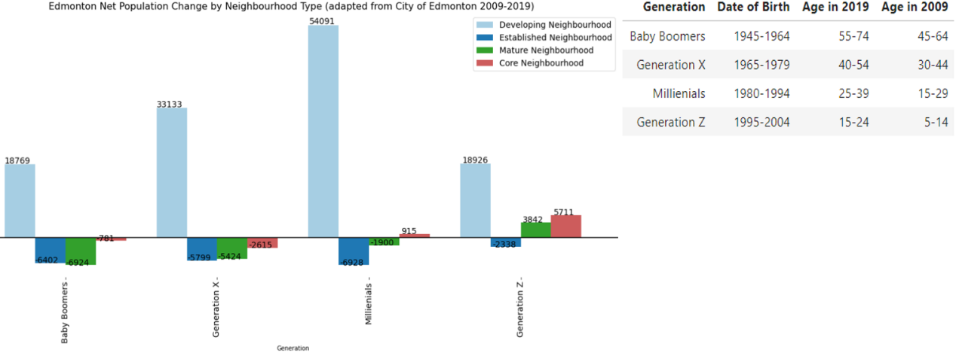

1. **Figure out the neighborhoods with lots of the target customer segment.**

According to the figures shown below, these are the neighborhoods with more than 8 Millennials per net residential hectare.

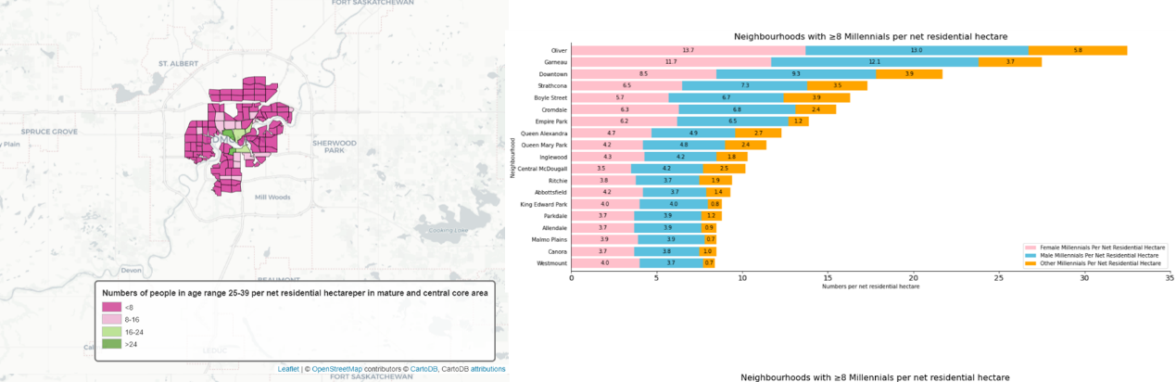

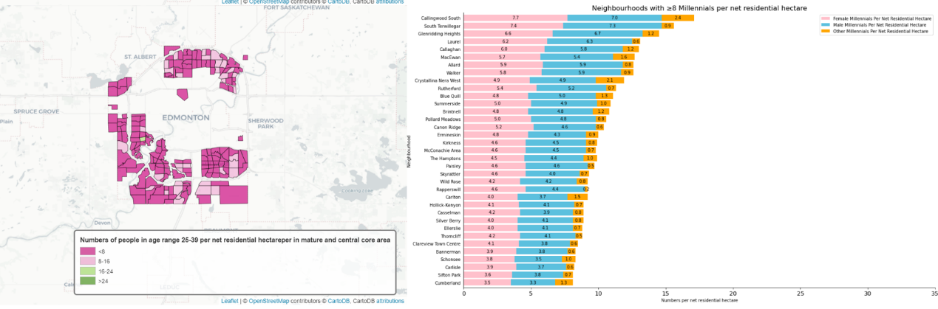

1. **Figure out the potential business location and the restaurant type.**

Then we need to evaluate the selected neighborhoods by:

1. Millennials density level
2. Single people density level
3. Family without child level
4. Commercial space available level (according to city’s zooning bylaw, only within certain areas of a neighborhood permit business behavior.)
5. Commercial assessment level (more existing business means more passanges flow in this area)
6. Passenger flow level (in this report, we focus on the passenger flow brings by the city’s subway/light-rail system)
7. Education level (people with higher education level tend to appreciate more on high quality food and give fair score to the restaurant during online evaluation.)
8. Income level
9. Tendency eating out level (for example, people own a dwelling tend to spend more compared to people without dwelling; people with mortgage tend to eat out more compared to people without mortgage; people living in urban tend to spend more on food purchase from the restaurant compared to people living in rural)

Based on the evaluation, we are looking for neighborhoods with

1. over 45% of the population in the selected neighborhoods have above **University education**
2. over 40% of the population in the selected neighborhoods are within **middle income class**
3. over 40% of the population in the selected neighborhoods are **single**
4. over 40% of the population in the selected neighborhoods are **without children**
5. equals to or above the average of the total score

The final selected neighborhoods are:

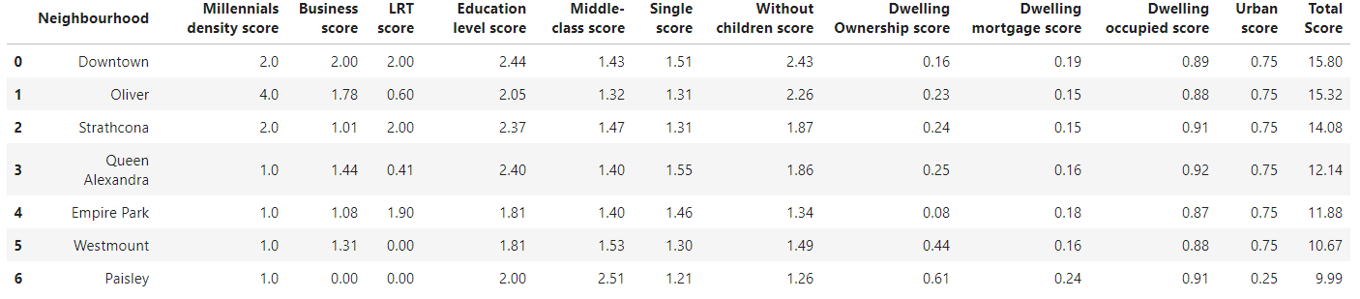

For **middle-class Millennials with above university education:**

1. Prefers a **cozy dining atmosphere**.
2. Prefer **fast casual, casual and premium casual** over traditional fast food like McDonalds or quit bites in a food court within a shopping center.
3. Prefers **something new but not too sophisticated**.
4. Prefer **fresh, natural ingredients**.

Summary of the evaluation details:

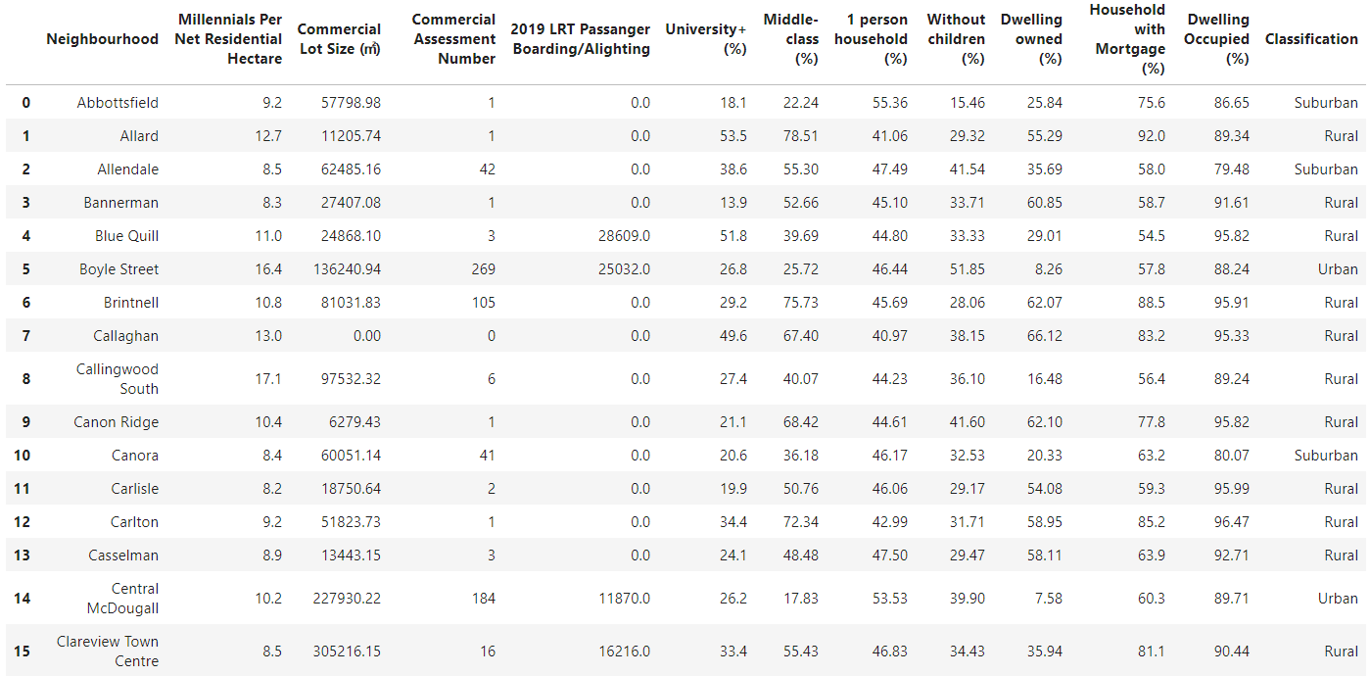

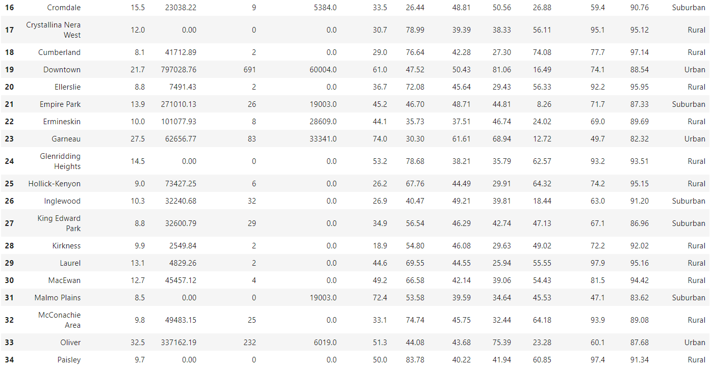

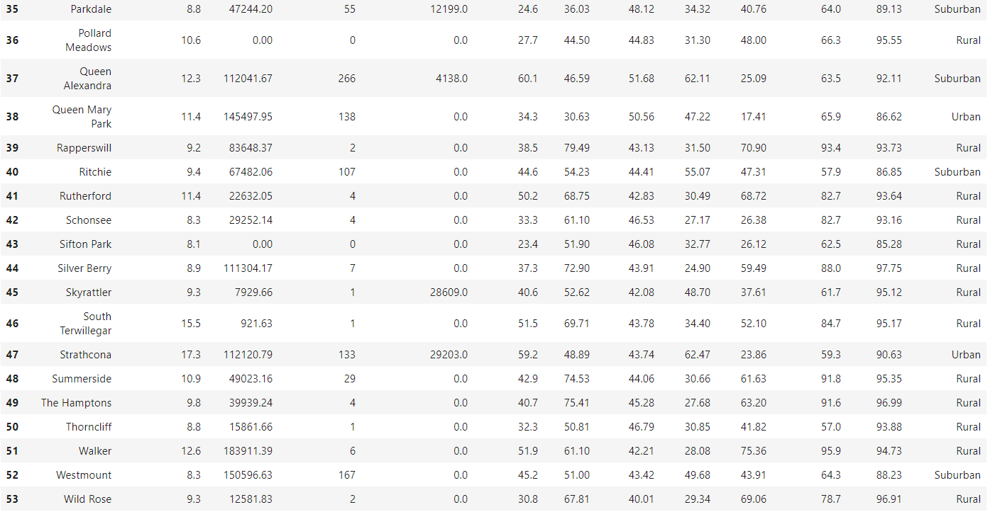

In terms of score (from highest to lowest):

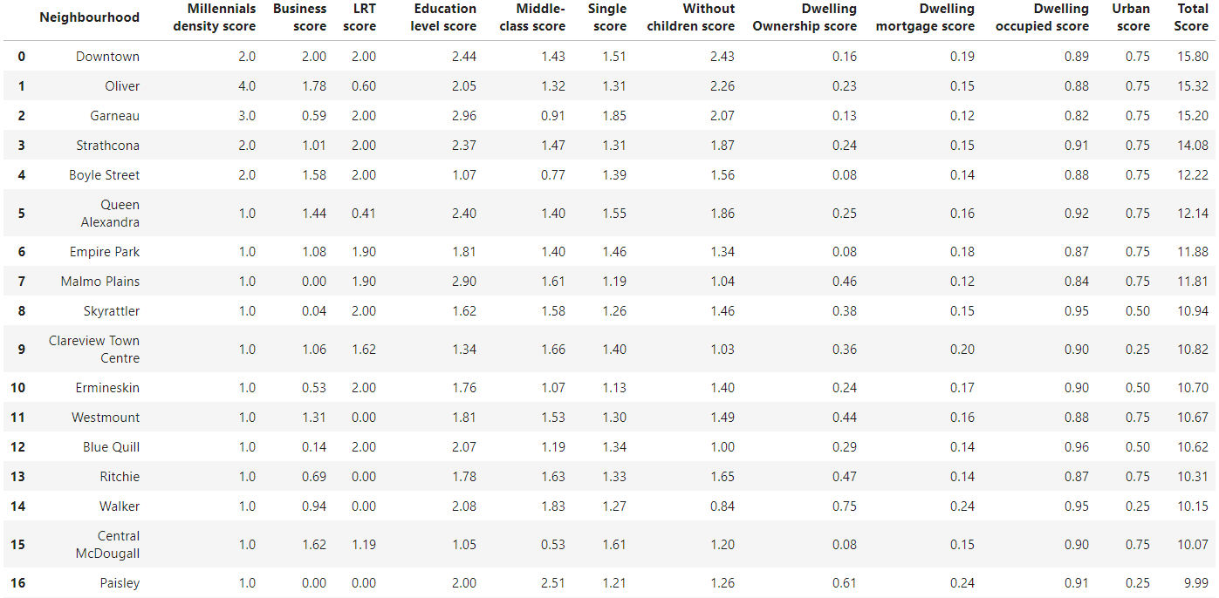

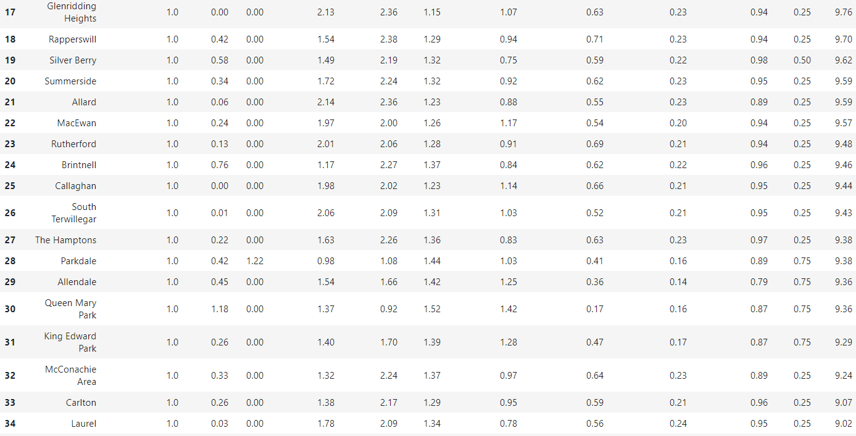

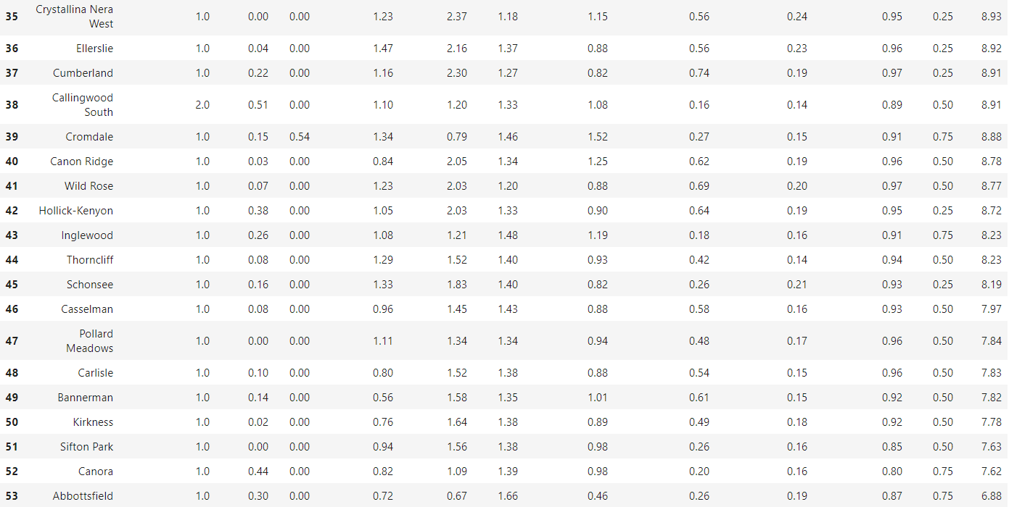

1. **Type of the ethnic cuisines:**

According to the existing restaurant types explored by Foursquare, Yelp and Zomato, we notice that **Paisley** is one of the best places to start up any restaurant.

Paisley is a new established neighborhood. In this neighborhood, there is **only one restaurant**, which is a Japanese casual dining restaurant. In this neighborhood, there is about 16.7% of the total population are immigrated from other countries, and half of them come from Asia, especially from China, Philippine and Korean. As a result, it is a good idea to start up either **a Chinese restaurant, or Filipino restaurant, or a Korean restaurant** in Paisley. Further, there is about 2.8% of the total population whose mother tongue is Spanish. As a result, Paisley will also provide the least competition for the new upcoming **Spanish restaurant**.

Paisley locates in **rural area**. This indicates that the **secondary target customer segments are people with families have child (Generation X and Baby Boomer generations)** **living in/near Paisley**.

**Empire Park:**

In Empire park, there is about 2.3% of the total population whose mother tongue is Spanish. However, based on the Foursquare, Yelp and Zomato AIP explore result, there is no Spanish restaurant in this neighborhood. As a result, Empire park will provide the least competition for the new upcoming **Spanish restaurant**.

**Queen Alexandra:**

In Queen Alexandra, there is 2.4%, 2.3% and 2.0% of the total population whose mother tongue is French, Persian and German, respectively. However, based on the Foursquare, Yelp and Zomato AIP explore result, there is no French, Persian nor German restaurant in this neighborhood. As a result, Queen Alexandra will provide the least competition for the new upcoming **French restaurant, Persian restaurant, and German restaurant**.

**Westmount:**

In Westmount, there is 2.3% of the total population whose mother tongue is Filipino. However, based on the Foursquare, Yelp and Zomato AIP explore result, there is no Filipino restaurant in this neighborhood. As a result, Westmount will provide the least competition for the new upcoming **Filipino restaurant**.

Empire park, Queen Alexandra, and Westmount locate in **Suburban area**. This indicates that the **secondary target customer segments are people with families and have child (Generation X and Baby Boomer generations)** **living in/near the neighborhoods.**

**Downtown:**

In Downtown, there is 2.3% of the total population whose mother tongue is Filipino. However, based on the Foursquare, Yelp and Zomato AIP explore result, there is no Filipino restaurant in this neighborhood. As a result, Downtown will provide the least competition for the new upcoming **Filipino restaurant**.

**Oliver:**

In Oliver, there is 2.1% and 2.0% of the total population whose mother tongue is Filipino and Spanish, respectively. However, based on the Foursquare, Yelp and Zomato AIP explore result, there is no Filipino nor Spanish restaurant in this neighborhood. As a result, Oliver will provide the least competition for the new upcoming **Filipino restaurant and Spanish restaurant**.

**Strathcona:**

In Strathcona, there is 2.8% and 2.1% of the total population whose mother tongue is French and Spanish, respectively. However, based on the Foursquare, Yelp and Zomato AIP explore result, there is no French nor Spanish restaurant in this neighborhood. As a result, Strathcona will provide the least competition for the new upcoming **French restaurant and Spanish restaurant**.

Downtown, Oliver, and Strathcona locate in **Urban area**. This indicates that, beside residential dining, the restaurant should also combine with commercial dining. Different from the suburban and rural areas, in urban area, the restaurant caters not only friends and families, but also customers, such as **professionals** and **alcohol-focused consumers**. This means there is a need for not only various table settings (2, 4 or 8 people table) but also various zooning settings (alcohol free or not). Additionally, diners in urban area are more likely to be influenced by social media and online reviews. Thus, it is important to update restaurant related information, such as menu and upcoming events, on social media on time, and maintain a good reputation at online review sites.

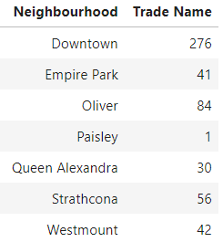

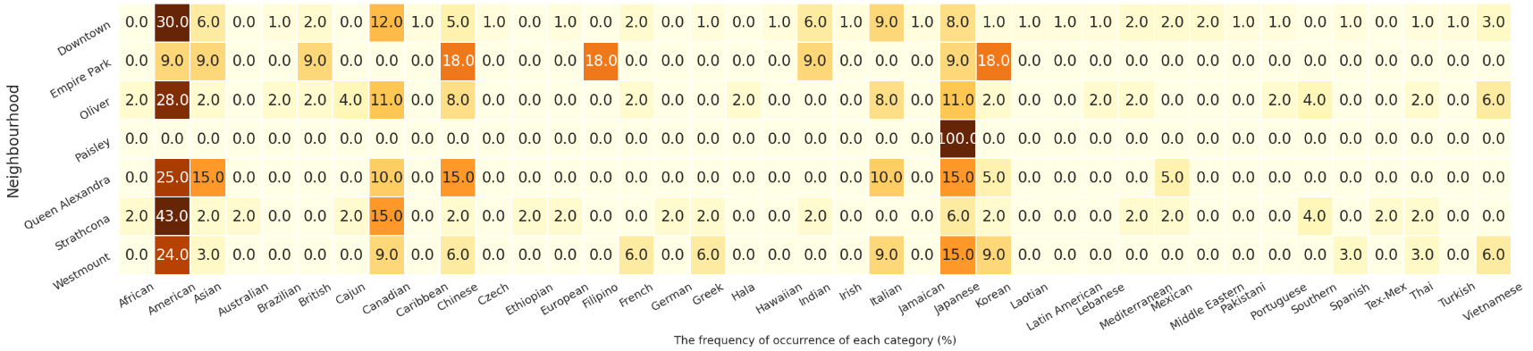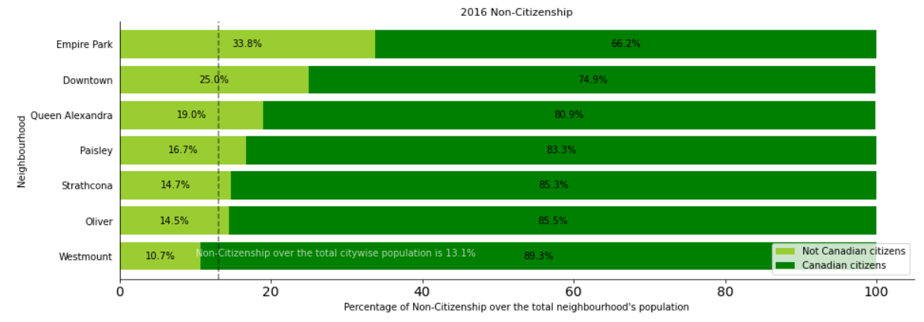

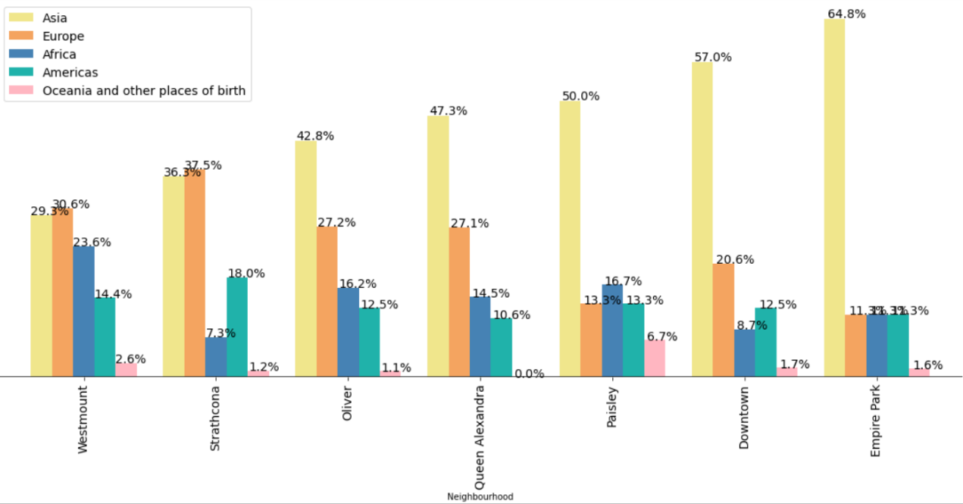

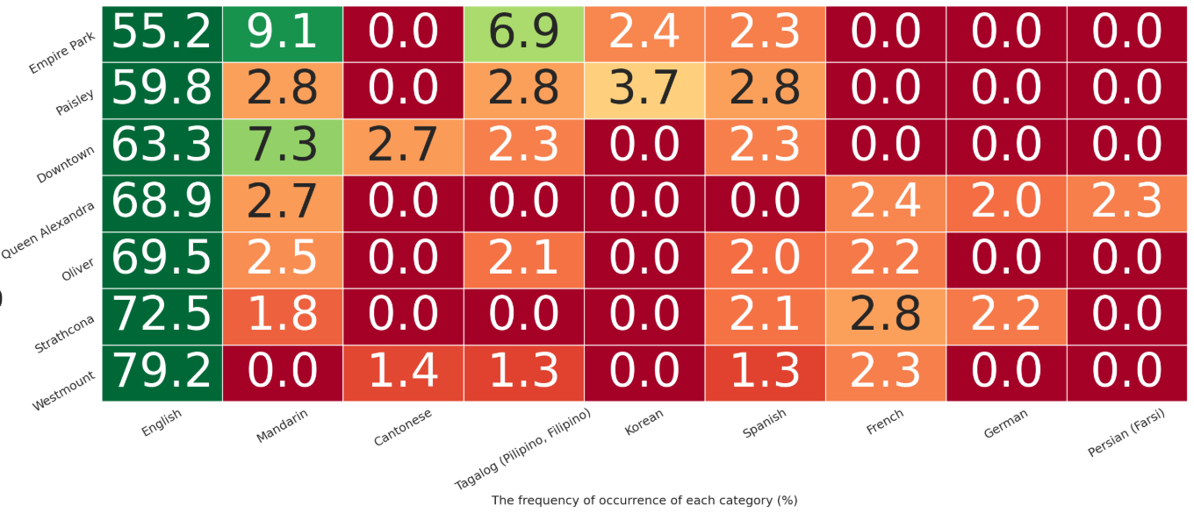

Downtown, Oliver, Strathcona, Queen Alexandra, and Westmount are also a potential travel destination, since there is/are Business Improvement Area(s) (BIA) in these neighborhoods. BIA is a specific geographic area of the city in which a group of property and business owners pool resources and work together, through a formal association, to create a more attractive and marketable image for the area and improve pedestrian experience in order to enhance the economic development of the neighborhood. Usually, BIA is promoted as a business, tourist or shopping area (business directories, festivals, advertising). As a result, the **secondary target customer segments are Tourists.**

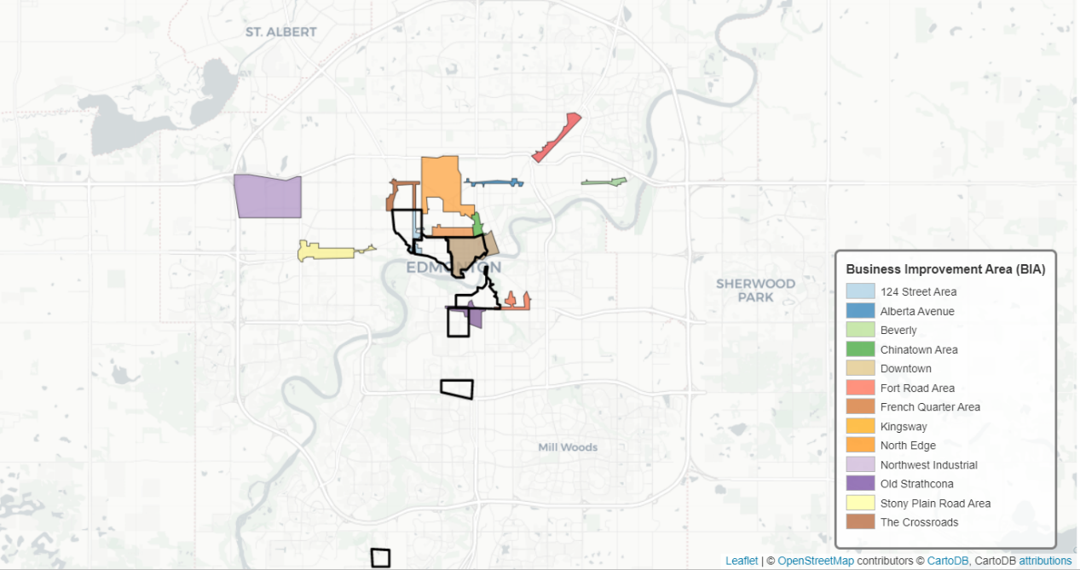

1. **Opening hour of the restaurant.**

Based on the mode commuting to work,

Paisley: Most of its residents needs to travel a long distance to work. Thus, they usually visit a restaurant on **weeknights, weekends, and holidays**. It will be better for the restaurant provide both eat in and takeaway services.

Downtown, Oliver, Strathcona, Queen Alexandra, Empire park, and Westmount: over 10% of their residents live and work in the same neighborhood. Additionally, since there are a large number of business assessments in these neighborhoods, there are also a large population travel from other neighborhoods to these neighborhoods to work. People usually visit a restaurant during **lunch hours**, **weeknights, weekends, and holidays**. It would be a good idea to offer business lunches and setup afternoon happy hours.

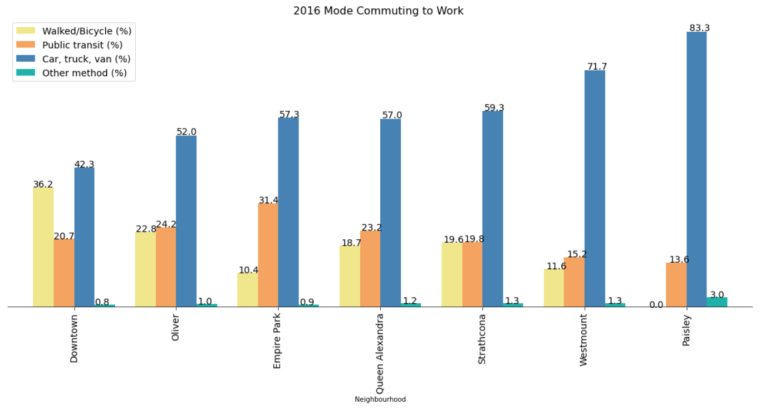

**Conclusion:**

Finally, to conclude this project, We have got a chance to on a business problem like how a real like data scientists would do. We have used many python libraries to fetch the data , to manipulate the contents & to analyze and visualize those datasets. We have made use of Foursquare, Zomato and Yelp API to explore the venues in neighborhoods of Edmonton, then get good amount of data from both the City of Edmonton open data bank and Statistic Canada and visualized using various plots present in seaborn, plotly & matplotlib. We also applied machine learning technique to predict the output given the data and used Folium to visualize it on a map.

Some of the drawbacks or areas of improvements shows us that this analysis can be further improved with the help of more data and different machine learning technique. Similarly we can use this project to analysis any scenario such as opening of a new gym and etc in Edmonton or opening a restaurant in another city. Hopefully, this project helps acts as initial guidance to take more complex real-life challenges using data-science.